Testing made easier by using SPSS

1) How to write tasks to make data entering as simple as possible

Test tasks must always be written in the way that what the test takers have to do is entered by letters and the questions are numbered.

Not like this:

a) Who is the best teacher in the school?

- Jane
- Jane's cousin
- Tom
- Eliot

But like this:

1) Who is the best teacher in the school?

- Jane
- Jane's cousin
- Tom
- Eliot

This might seem quite obvious but in some types of multi-matching tasks item-writers tend to prefer the first way because they say it is more test taker friendly. The truth is there is no empirical data for that and the process of test analysis becomes more complicated and time consuming.

2) What should the piloting population be like?

The piloting population should be normally distributed. The most important thing is that we have very weak and very strong students in our piloting population and it should be as similar to our testing population as possible. Only when we have data on students with a variety of abilities, the statistical results will show us how the item will behave with those students. Will the majority of strong students get the item right and will the majority of weak students get it wrong – or is it maybe the other way round?

3) How to enter the data?

Double click on the SPSS icon and you will get the following window on your screen:

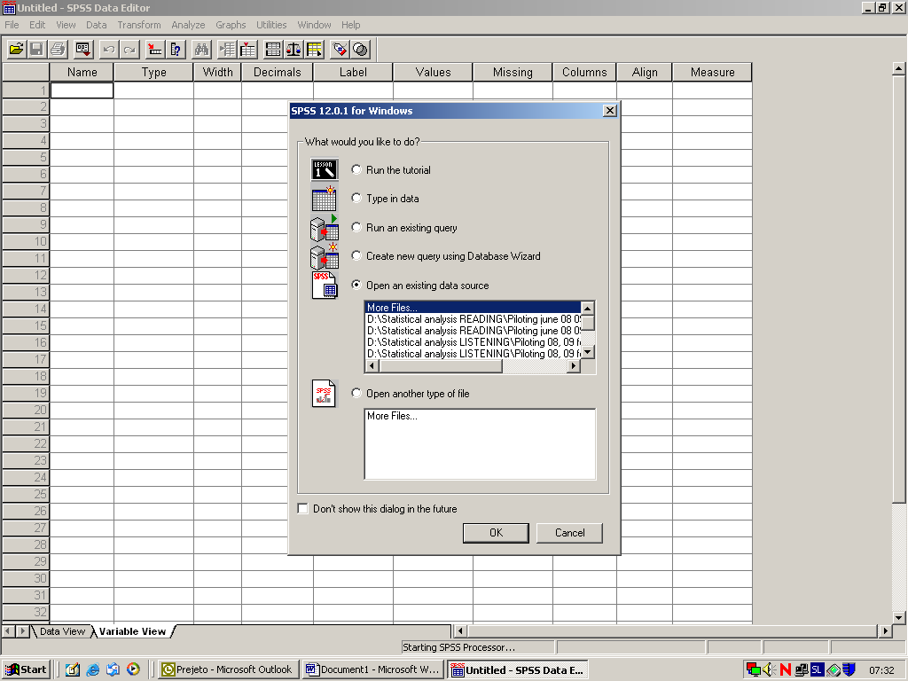

Click Type in data and then OK and a new spreadsheet fill appear on your screen.
There are two views of what you enter into SPSS: Data view (the data on how the test takers performed) and Variable view (the data on your variables/items).
First you have to go the Variable view to define your variables. The following window appears on your screen:
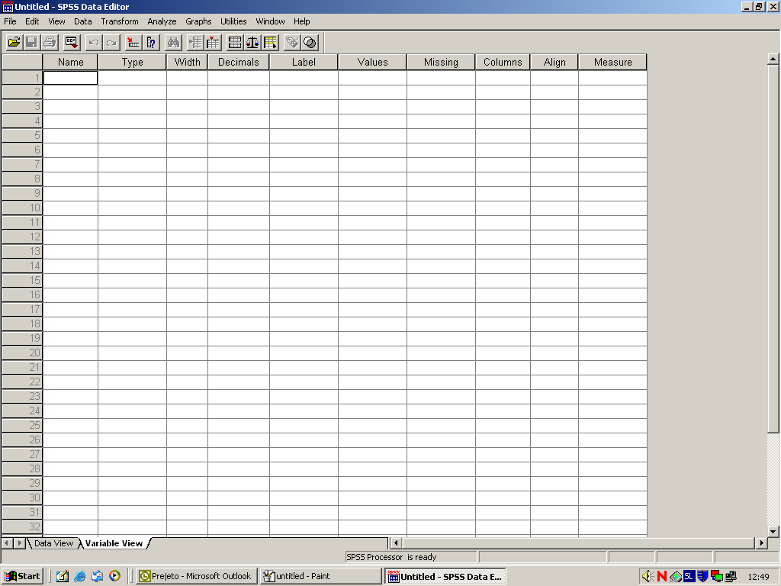
You enter important data about all the variables/items in a test. In the beginning you enter all variables on biographical data (gender, position, rank, region, school, teacher, course book, course) and index number. It is important to limit data to what you can, wish or have to analyze.

In the beginning we enter letters to check the performance of distractors (string variables!).

In the end the Variable view should look something like this:

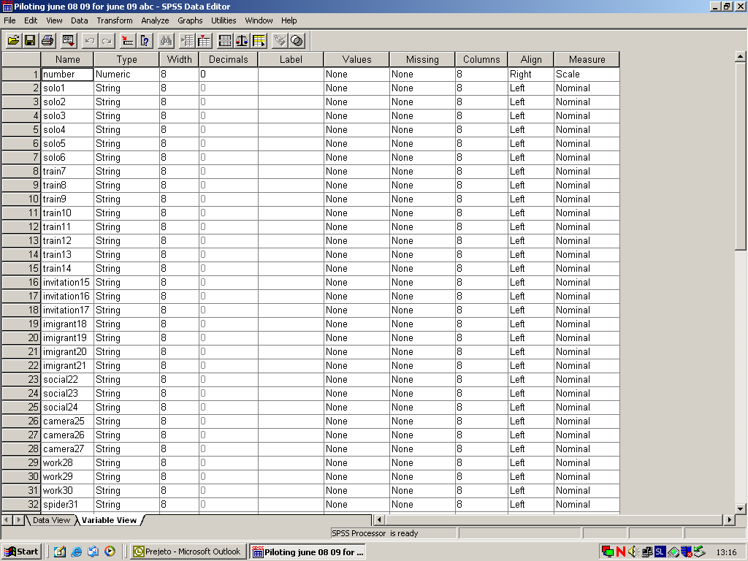

After that you go back to the Data view by clicking on it and you enter the data. Do not forget to label biographical data.

For multi matching and multiple choice items enter the letters as written by the test takers. For short answers you have to assign letters to different answers (two or more categories).

After entering the data check if everything is OK. Explore different ways of checking the data.

When all the data is entered and checked your Data view should look like this:

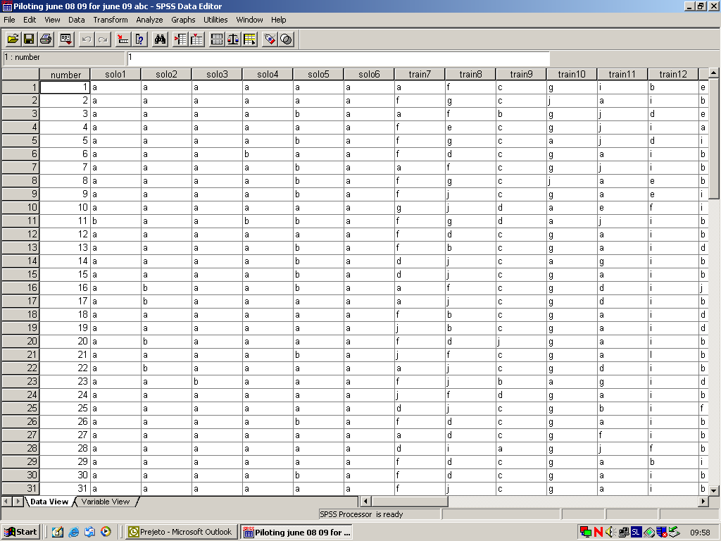

4) Descriptive statistics
At this moment you are ready for the simplest analysis of the data called the descriptive statistics which will basically give you the information about how many test takers (the percentage) chose a particular distractor.

To do the analysis click on Analyze then go to Descriptive Statistics and click Frequencies:
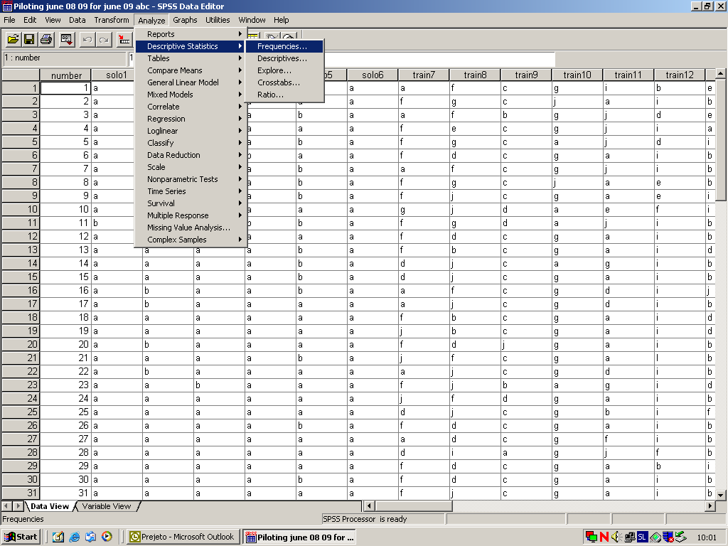

The following window will appear:
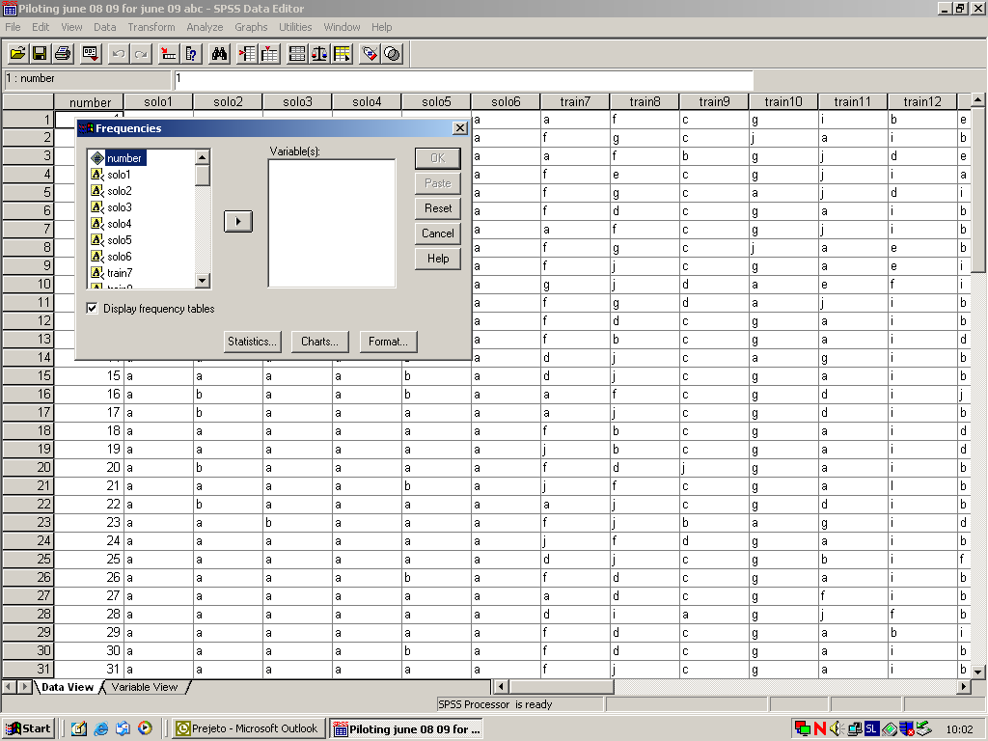

Move all the items to the active window and click OK (do not move the biographical data):
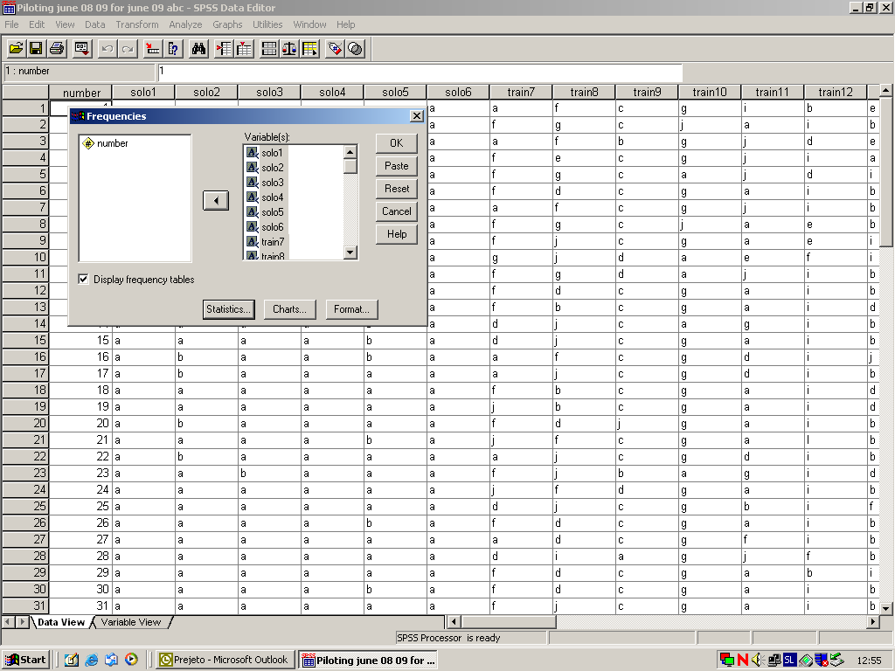

And you get the results in the output window:

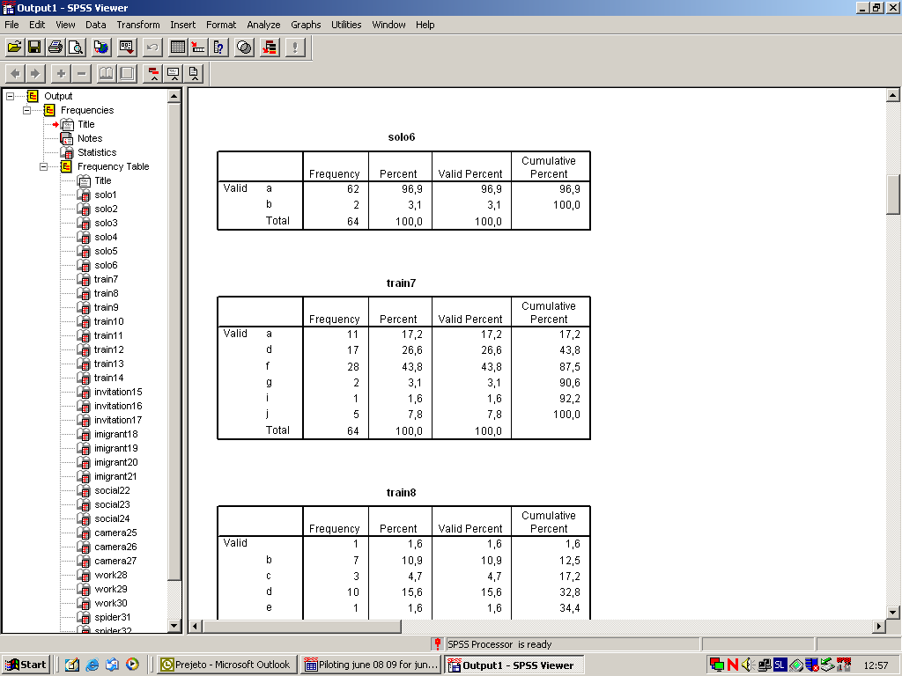

You can save the output by clicking File and then Save as. Think about you decide to print the output files because they can be very paper consuming.

After analyzing how many test takers chose a particular answer we are interested in who were the test takers who chose the correct answer (weak or strong students) and if the test was testing what it was intended to test and was therefore reliable.

5) Recoding and final score

To perform the reliability analysis we need to prepare the file first. We do that by recoding our data. From string variables (letters) we recode the data into numeric variables (0 for all incorrect answers, 1 for correct answers).

Always make a copy of the file before you start recoding to keep the original file. This is very important because the UNDO function DOES NOT WORK in the recoding process.

Recode so that the new variables replace the existing ones because it is much easier to work with such a file.

Click on Transform, go to Recode and click on Into Same Variables:
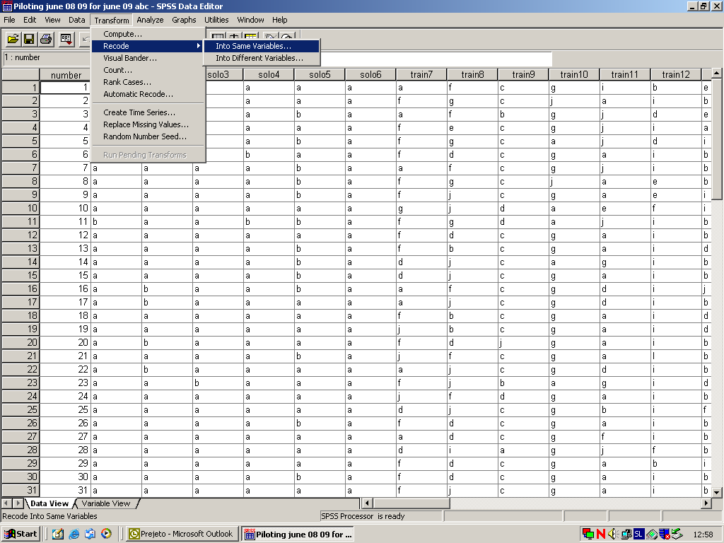

In the following window move into the active window all items for which the correct answers was A:
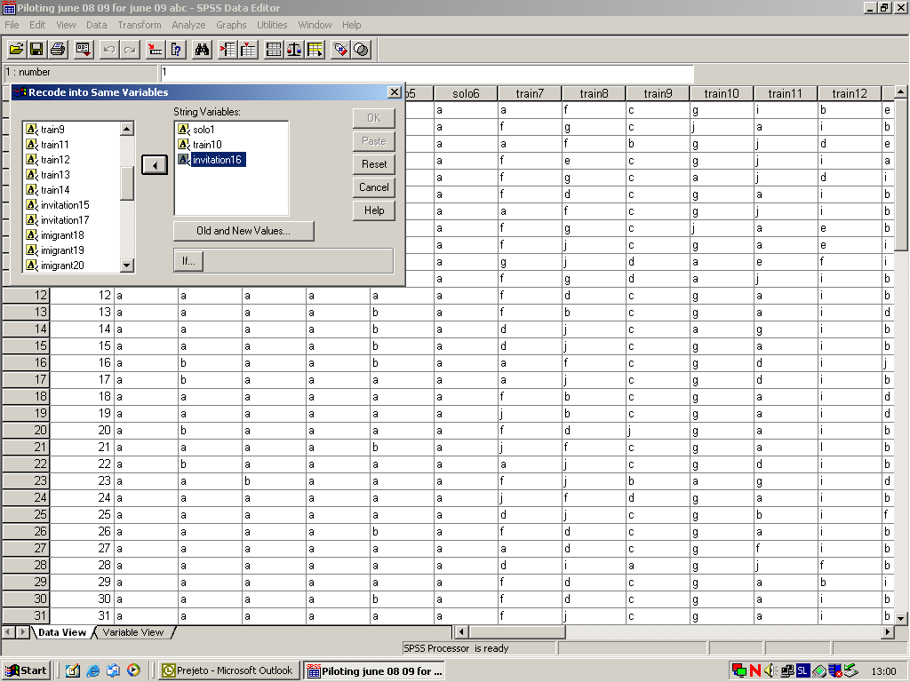

Then go to Old and New Values, enter the new values, click continue and OK:
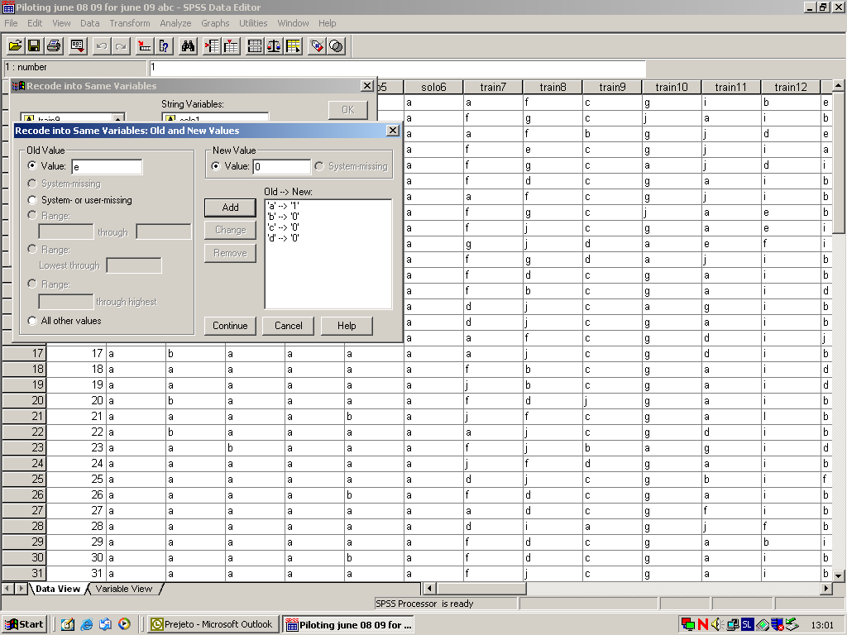

You new file will gradually change. You have to repeat the process of recoding with all letters and all items.
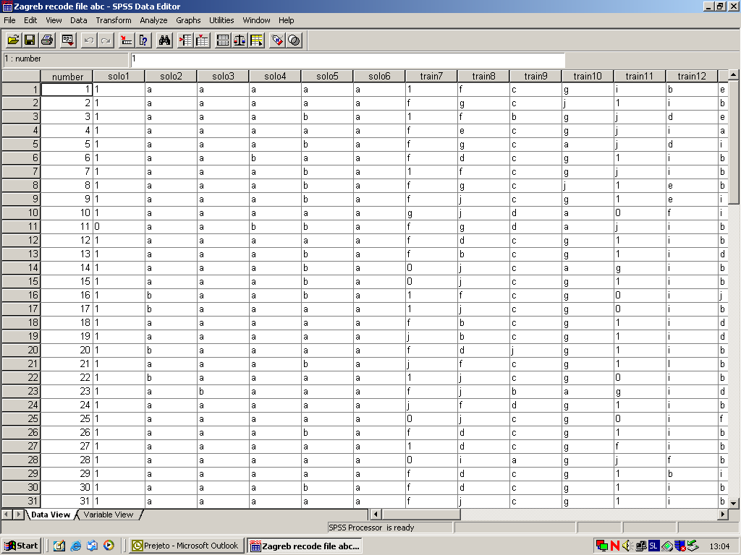

Until your file looks like this:
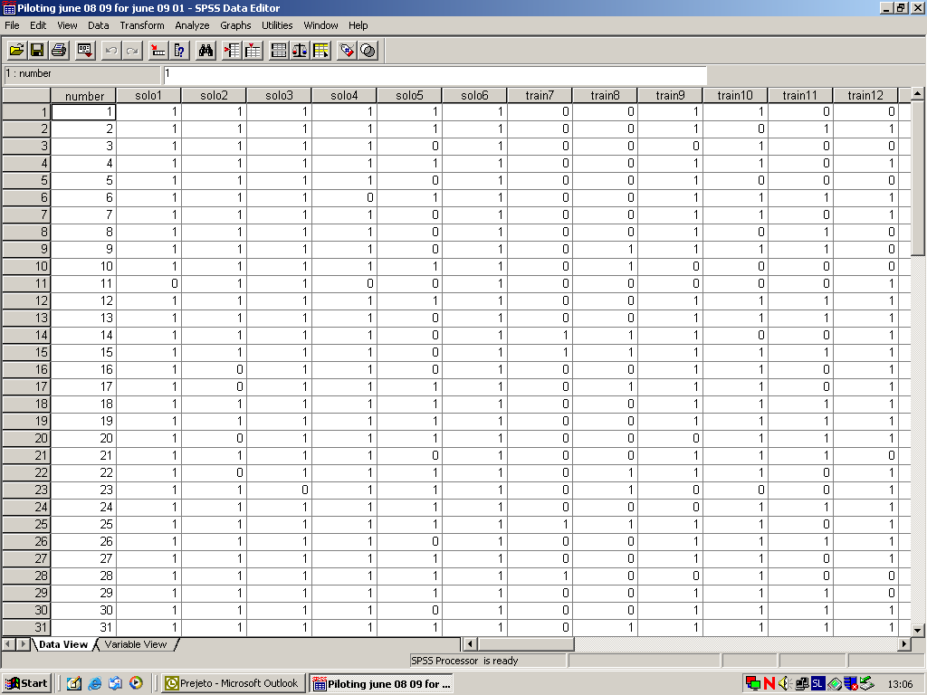

Do not forget to go to the Variable view and redefine your variables into Numeric:
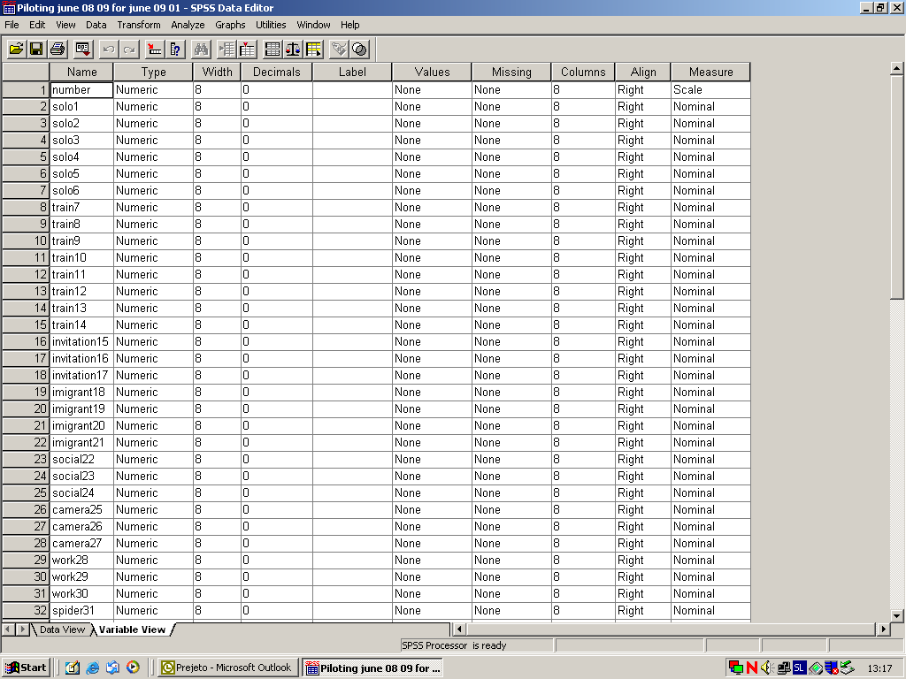
Do not forget to save the changes.

Before we go to reliability analysis it might be a good idea to count or check our final scores. If we assigned one point to each correct answer then it is very easy to do it with the Count function.

Click on Transform and then on Count:

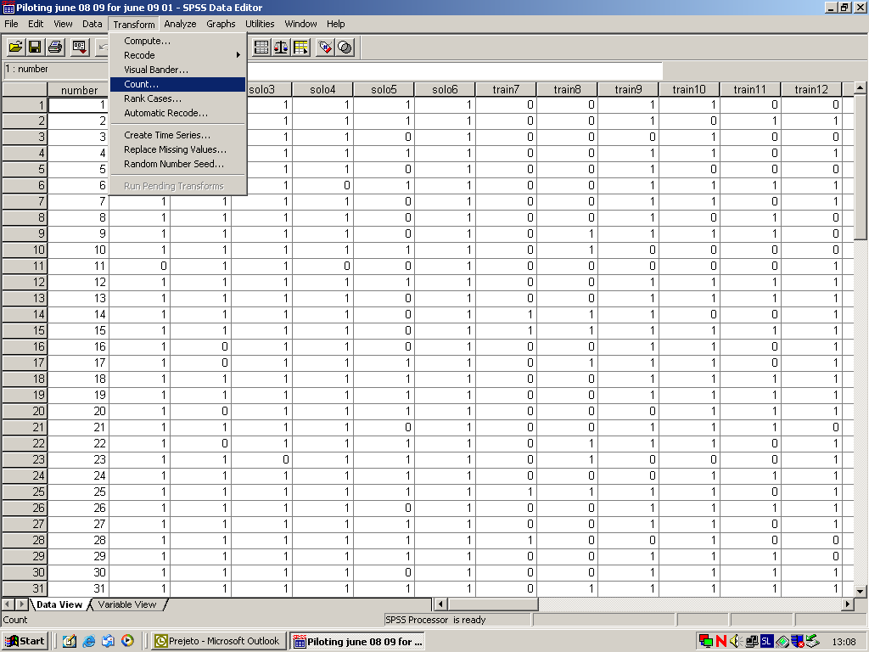

Name and label the target variable (like: score) and move all items to the active window. Do not move the biographical data.
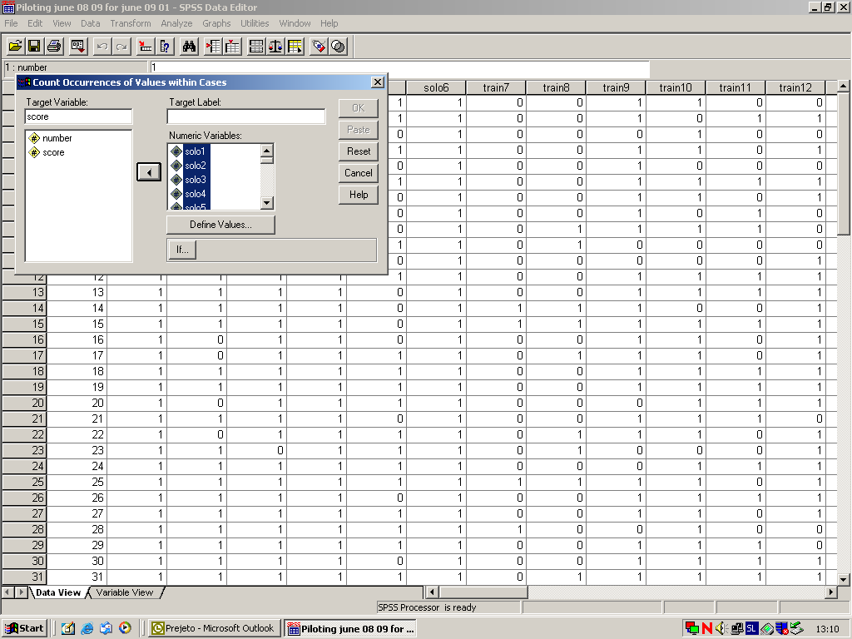

Define value to count (1) and click Add, Continue and OK:
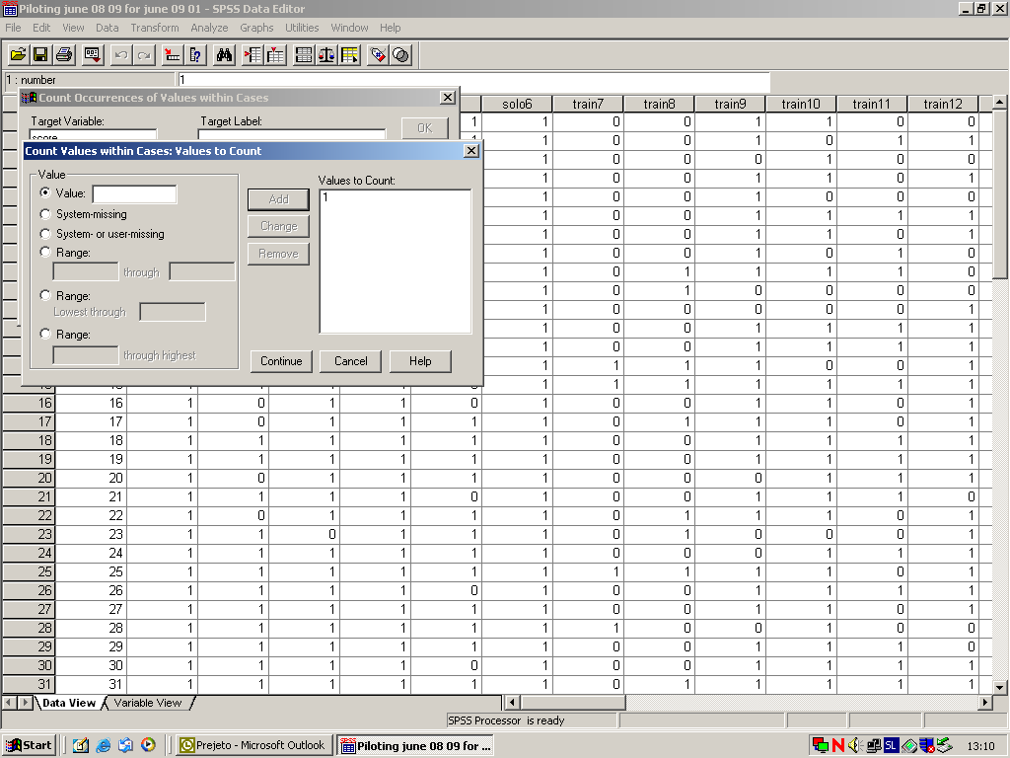

The new variable will appear at the end of the data file.
The final score variable helps us to check the final scores which were assigned manually and serves as a base for analyzing our testing population (normal distribution).

6) Reliability analysis

Now we are ready for reliability analysis. Click on Analyze, go to Scale and click on Reliability Analysis:

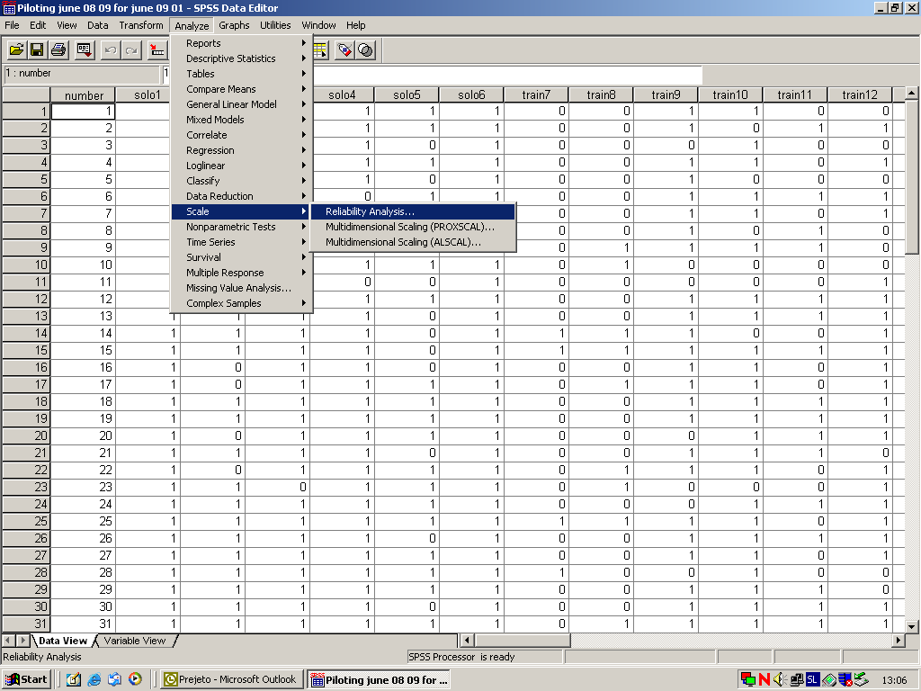

Move all items (without the biographical data and the score) to the active window:

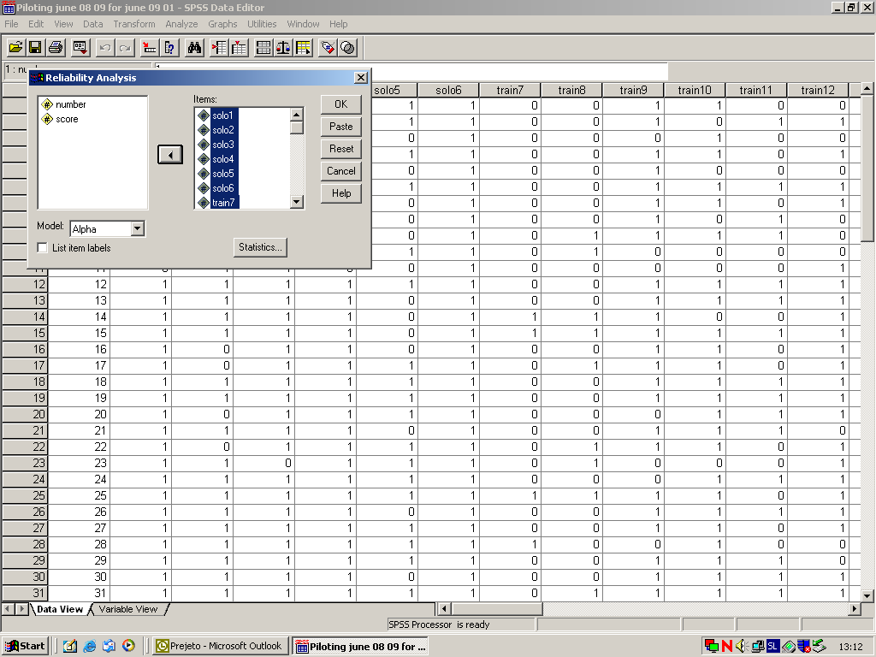

Click on Item, Scale, Scale if item deleted, Continue and OK:
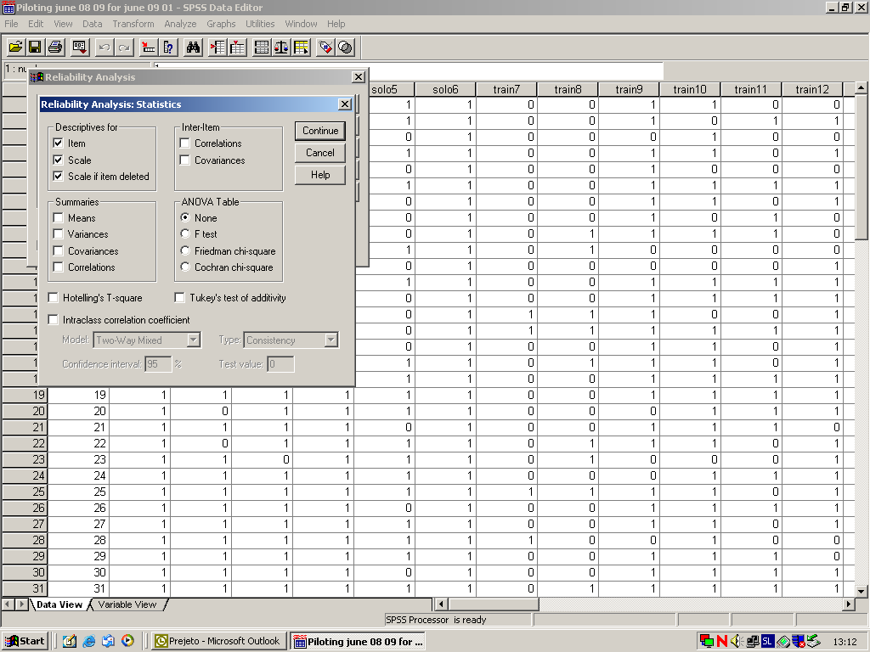

The following data will appear in the output window:

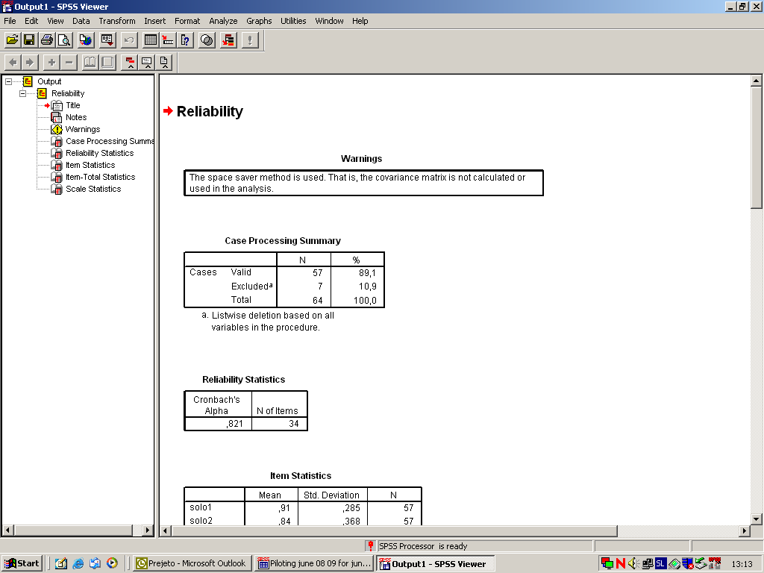

Cronbach’s Alpha tells us about how reliable the test is. Remember that it is greatly affected by the number of items. If the test is very short than the Alpha will be lower. More items produce a more reliable test (but there are of course limits to that rule). To have a reliable test tool Alpha should be higher than .8.

Alpha is also (or primarily) affected by the discrimination indices. We find them in the Corrected Item Total Correlation column. Their values should be above .3 (or .25). Low or negative values affect the value of Alpha. In our test we can see that although the test was reasonably long, the value of Alpha is acceptable but not very high. If we check the discrimination indices we see that some are very low or even negative which affects the reliability of the test. As the data comes from the piloting phase of the test development this is what we expect. Some items always have to be revised or even discarded after this phase.

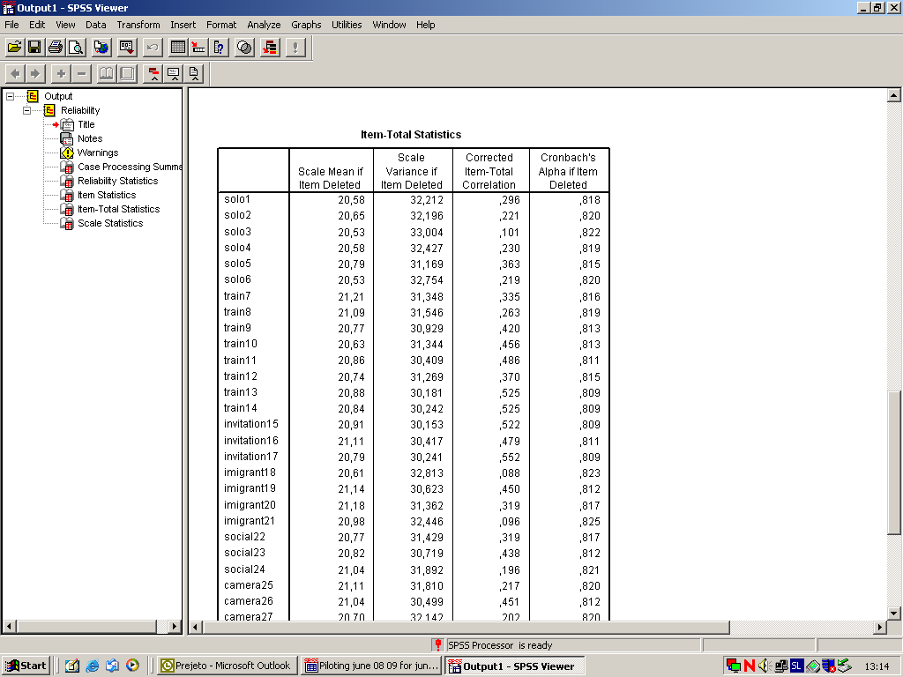

You can save the output by clicking File and then Save as. Think about you decide to print the output files because they can be very paper consuming.

Remember that you have to check the distribution of the population before you do the reliability analysis as the reliability of all correlation coefficients depends to a large degree on the normal or near normal distribution of the population.

Final note:
If you use or will use the SPSS software please remember that language testers use a tiny part of the programme and that there are many other possibilities to explore even further. It is also important to know that any old version of the programme will suffice for what language testers use the programme for.

For more ideas go to the SPSS website, contact your local SPSS dealer or consult the following books:

Salkind, Neil J., Statistics for People Who Think They Hate Statistics, 3rd edition; Sage Publications, Inc., 2008

Pallant, Judith, SPSS Survival Manual, 3rd edition; Open University Press, 2007

